**Detailed Specification**

You have been tasked as a Front-End Web Developer a simple resume webpage for you. See below the design that the “Graphic Designer” **mocked up** in Figure 1.1 **Also,** download the images required for the website from the link :<https://drive.google.com/drive/folders/1q7sORDPMB1IwvDUltEHvMHGj0s4ZQQ8u?usp=sharing>

**Figure 1.1 Home Page**

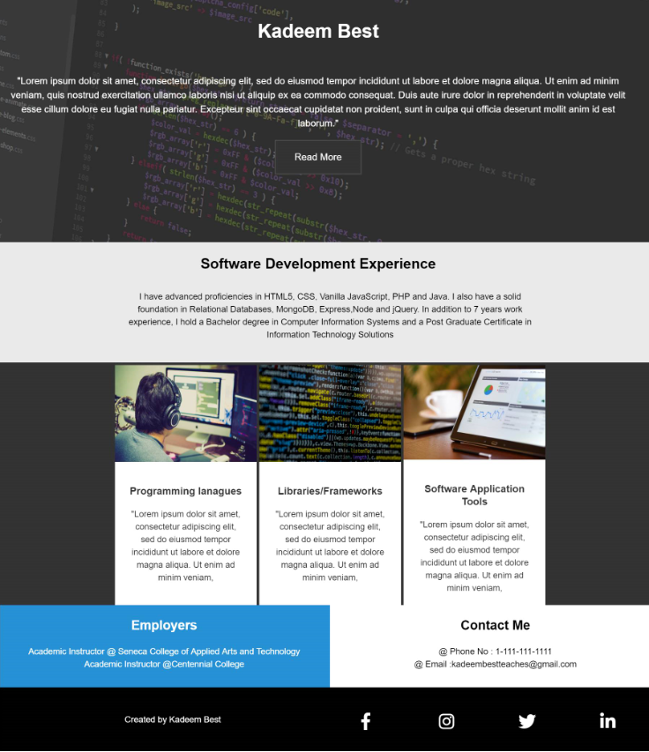

# **Rules:**

1. Set the words throughout the webpage to be Arial
2. Set the size of the font to be 1.1rem
3. Set the spacing between lines to be : 1.4rem
4. The Height of this area (Figure 1.2) should be 60% of the viewing port. Also, replace “Kadeem Best” with your name and replace the lorem ipsum with a paragraph about you and your skillset, similarly as you would on a resume

**Figure 1.2**

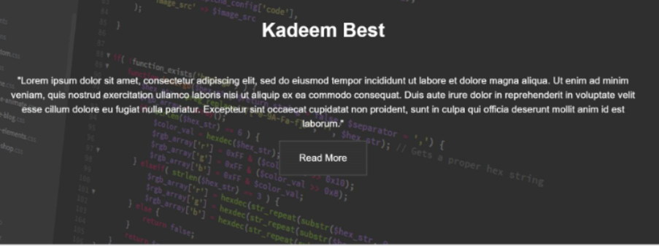

1. For this area (Figure 1.3), put a paragraph about your experience as a Software Development.

**Figure 1.3**



1. For this area (Figure 1.4), specify paragraphs regarding the programming languages, libraries and software application tools that you are proficient in.

**Figure 1.4**

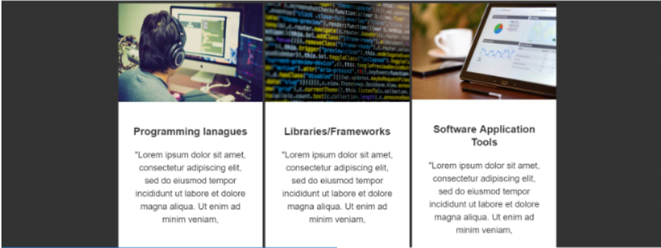

1. Use the <https://imagecolorpicker.com/en/> tool to determine the background colors and text colors of the sections and areas throughout the page.
2. For the below area (Figure 1.5), state that it was created by you. Put your name and student id. For each of the social media links, ensure that icons link to any external websites of your choice.

**Figure 1.5**



1. Apply all the appropriate css rules to get the page to look exactly like the design in Figure 1.1